

Keep Children Safe

We want children to enjoy fireworks but they need to know that they can be dangerous if they are not used properly. Each year, over half of all firework injuries are suffered by children. The Child Accident Prevention Trust have more guidance on keeping kids safe.

Keep Children Safe

*Did you know that sparklers get five times hotter than cooking oil? Sparklers are not toys and should never be given to a child under five.*

Having fireworks at home can be great fun, as long as they are used safely. Figures show more children rather than adults get hurt by fireworks. Over the past few years over 350 pre-school children, some only a year old, were treated in hospital for fireworks injuries.

A torch

A bucket or two of water

Eye protection and gloves

A bucket of soft earth to put fireworks in

Suitable supports and launchers if you’re setting off Catherine wheels or rockets.

Firework displays

On the night, you will need:

Where to buy

Don’t cut corners just to save a few pounds. Always buy fireworks from a reputable shop to make sure that they conform to British Standards. This means that they should have BS 7114 written on the box.

Sometimes shops open up for a short time before Bonfire Night but these may not be the best places to buy fireworks from. Staff in these shops might not be very knowledgeable about using fireworks safely and their fireworks might not meet British Standards.

Whatever you do, don’t buy fireworks from anywhere you’re not sure about, such as the back of a van or from a temporary, unlicensed market stall.



Be safe not sorry

Fireworks are safe if you use them properly. If you’re putting on a home display, you should follow some simple steps to make sure that everyone has a good time without getting hurt.



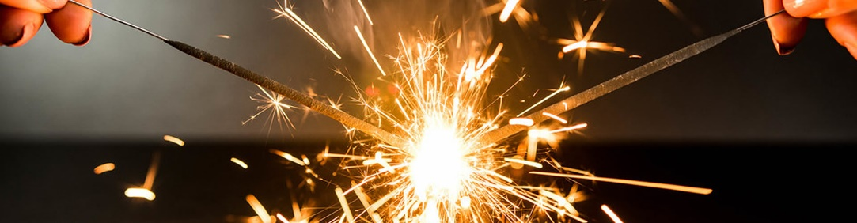

What to buy

There are different categories of fireworks. Members of the public can buy and set off most of the fireworks that come under Categories 1 to 3. These are fireworks that include those that you can use indoors, in your garden or at a display. Always read the packet carefully and make sure that the fireworks you buy are suitable for the place where you are going to set them off.

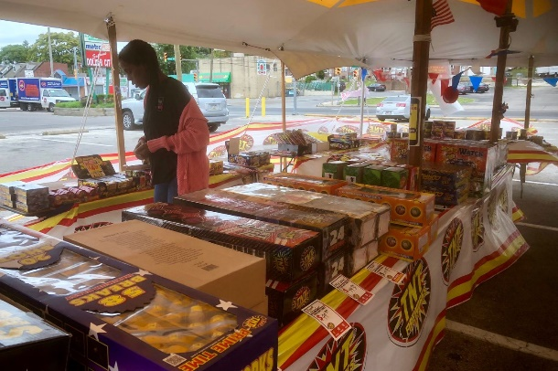

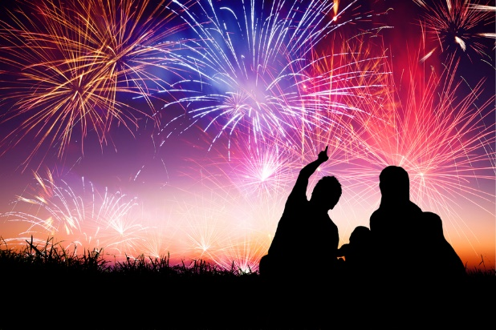

Only one person should be in charge of fireworks. If that’s you, then make sure you take all the necessary precautions. Read the instructions in daylight and don’t drink any alcohol until they’ve all been discharged. Make your preparations in advance, and in daylight.

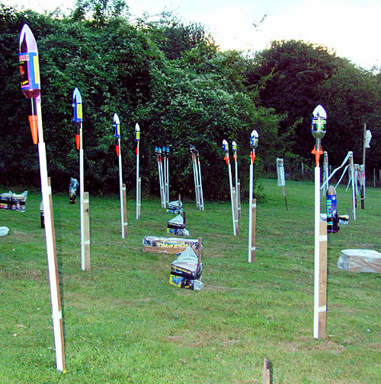

Setting them up

Professional fireworks

Some fireworks can only be bought and used by firework professionals. These include: air bombs; aerial shells, aerial maroons, shells-in-mortar and maroons-in-mortar; all bangers; mini rockets; fireworks with erratic flight; some Category 2 and 3 fireworks which exceed certain size limits; and all Category 4 fireworks.

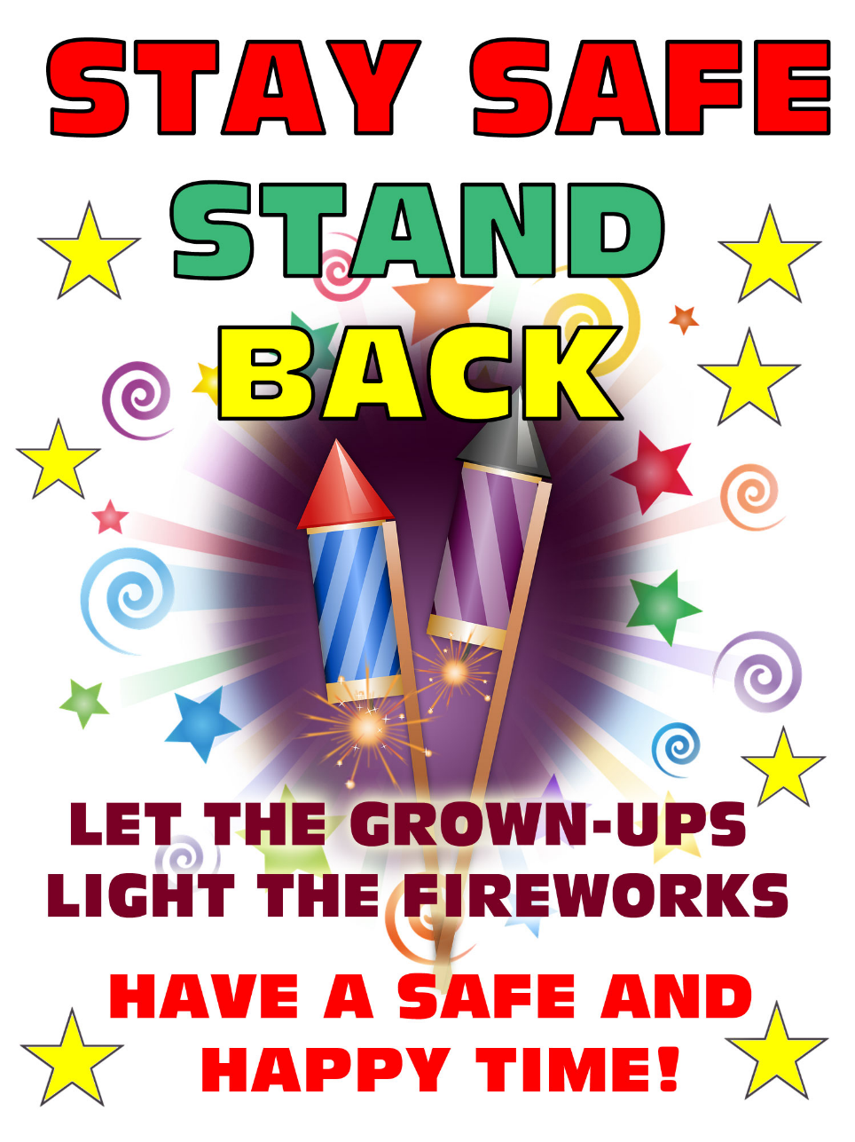

**Answer the following questions in your exercise books based on the text:**

1. **How old should you be to be able to hold a sparkler?**
2. **What proportion of children get injured by fireworks compared to adults?**
3. **How hot can sparklers get?**
4. **How many categories of fireworks are there?**
5. **What should be written on a firework to make sure it means British Standard? What could be the problem if the firework has not got this written on it?**