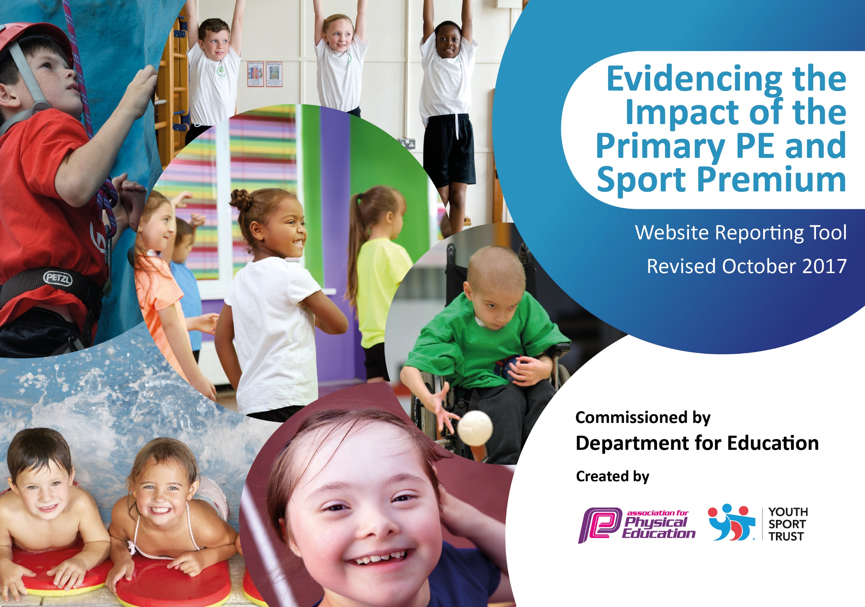

Schools must use the funding to make additional and sustainable improvements to the quality of PE and sport they offer. This means that you should use the Primary PE and Sport Premium to:

- develop or add to the PE and sport activities that your school already offers
- build capacity and capability within the school to ensure that improvements made now will benefit pupils joining the school in future years

Please visit gov.uk for the revised DfE guidance including the 5 key indicators across which schools should demonstrate an improvement. This document will help you to review your provision and to report your spend. DfE encourages schools to use this template as an effective way of meeting the reporting requirements of the Primary PE and Sport Premium.

We recommend you start by reflecting on the impact of current provision and reviewing the previous spend.
Under the Ofsted Schools Inspection Framework, inspectors will assess how effectively leaders use
the Primary PE and Sport Premium and measure its impact on outcomes for pupils, and how effectively governors hold them to account
for this.

Schools are required to publish details of how they spend this funding as well as on the impact it has on pupils’ PE
and sport participation and attainment.
We recommend regularly updating the table and
publishing it on your website as evidence
of your ongoing review into how you are using the money
to secure maximum, sustainable impact. To see an example of how to complete the table please click HERE.

Support for review and reflection - considering the 5 key indicators from DfE, what development needs are a priority for your setting and your students now and why? Use the space below to reflect on previous spend, identify current need and priorities for the future.

Key achievements to date: | Areas for further improvement and baseline evidence of need:
- School Games Kitemark GOLD – 2016/17 (improved from SILVER 2015/16)  - Y5&6 East Staffs Rounders Winners | - Collect swimming data to meet government requirements.  - Achievement in competitions  - Improve overall fitness of students in Y5&6  - Have a representative on the school council

Meeting national curriculum requirements for swimming and water safety | Please complete all of the below:
What percentage of your Year 6 pupils could swim competently, confidently and proficiently over a distance of at least 25 meters when they left your primary school at the end of last academic year? | 73%
What percentage of your Year 6 pupils could use a range of strokes effectively [for example, front crawl, backstroke and breaststroke] when they left your primary school at the end of last academic year? | 62%
What percentage of your Year 6 pupils could perform safe self-rescue in different water-based situations when they left your primary school at the end of last academic year? | Unknown
Schools can choose to use the Primary PE and Sport Premium to provide additional provision for swimming but this must be for activity over and above the national curriculum requirements. Have you used it in this way? | Yes. Y5 non-swimmers go to weekly lessons NOT paid by SP. Y6 curriculum swimming in the Summer term funded by SP.

Action Plan and Budget Tracking
Capture your intended annual spend against the 5 key indicators. Clarify the success criteria and evidence of impact that you intend to measure to evaluate for students today and for the future.

Academic Year: 2017/18 | Total fund allocated: £ | Date Updated:
Key indicator 1: The engagement of all pupils in regular physical activity – Chief Medical Officer guidelines recommend that primary school children undertake at least 30 minutes of physical activity a day in school |  |  |  | Percentage of total allocation:
 |  |  |  | 20%
School focus with clarity on intended impact on pupils: | Actions to achieve: | Funding allocated: | Evidence and impact: | Sustainability and suggested next steps:
Increased participation levels in relation to the Governments targets. | 3x afterschool clubs a weekly | £1650 | Increased activity levels and improved attainment levels in PE.  Regsiters. | Continue with the after school clubs next academic year.
Increased participation levels in relation to the Governments targets. | Lunchtime coaches providing 3x lunchtime clubs | £0 | Improved behavior in ‘free time’.  Increased activity levels and improved attainment levels in PE.  Certain students / groups of students targeted intervention through LT clubs.  Registers. | Use the Young Leaders (along with PE staff) to provide extra lunchtime provision.
Key indicator 2: The profile of PE and sport being raised across the school as a tool for whole school improvement |  |  |  | Percentage of total allocation:
 |  |  |  | 15%
School focus with clarity on intended impact on pupils: | Actions to achieve: | Funding allocated: | Evidence and impact: | Sustainability and suggested next steps:
Inter House program active throughout the year. | Termly house competitions in the school calendar.  Invite parents to watch events. | Young Leaders trained as part of the Pyramid payments. | Large number of students competing in Level 1 competitions.  Young Leaders demonstrating organization skills to help run events.  Supports the whole schools House system.  Data collection. Photographs. | Continue to build on the program introducing more sports. (Table Tennis introduced in the summer term).
Maintaining the Gold School Games Kitemark Award to evidence that PE is embedded throughout the School. | Attendance at competitions and events and continue to maintain the figures needed. | Transport to events. | Raise profile of school success through the schools social network and website. | Liaise with the Sports Council leader to have a Sports representative on the council.  Communicate with the new Governors.  Updating ALL school staff on SP plan and impact. Achieved summer term.

Key indicator 3: Increased confidence, knowledge and skills of all staff in teaching PE and sport |  |  |  | Percentage of total allocation:
 |  |  |  | 20%
School focus with clarity on intended  impact on pupils: | Actions to achieve: | Funding  allocated: | Evidence and impact: | Sustainability and suggested  next steps:
To attend network and pyramid meetings. | Cover requirements. | Cover costs | The sharing of best practice amongst staff.
Using specialist coaches to deliver certain activities in curricular time. | Delivery of high quality PE.  CPD for WPMS PE Teachers (observing / team teaching). | £3389 | Improved teacher knowledge. High quality teaching provision.  Increased participation of extra- curricular and out of school clubs.  Coaches have inspired the students. | Newly acquired knowledge of the teachers can be applied in future lessons.
Key indicator 4: Broader experience of a range of sports and activities offered to all pupils |  |  |  | Percentage of total allocation:
 |  |  |  | 30%
School focus with clarity on intended  impact on pupils: | Actions to achieve: | Funding  allocated: | Evidence and impact: | Sustainability and suggested  next steps:
Increase the number of students taking part in extra-curricular activities. | Varied extra-curricular program in place throughout the year.  New equipment purchased to offer more sports. | Cost of club providers as mentioned above.  Cost of new equipment - £868.36 (lesson equipment too) | Data collected from club registers. | New clubs can continue due to new equipment.
Provide extra swimming session to students in year 6 to ensure the reach the required objectives (25m) | Swimming in curricular time (Summer 1) arranged with Neil Brown at the Borough Council. | £840 | Attainment data collected at the end of the SOW. | Continue to use this already set up arrangement next year.
Provide students with an OAA experience. | Arrange climbing trip for Y5 students. | £765 (transport not incl) | Students enthused by a new activity.  Photographs. Pupil voice. | Create a pathway for students to continue if they enjoyed it.
Provide all students with a wide range of sports to engage in during NSSW. | Liaise with the SGO and local providers. Create a timetable of events in lessons and lunchtimes. | £500 | Students enthused by new activities.  Increased activity levels of students.  Pupil voice. Photographs. | Create a pathway for students to continue if they enjoyed particular activities.
Provide students in Y6 with a Health Workshop. | This has been arranged with The A-Life team for Sumer 2. This will complement the already in place Chnage4Life lunchtime club. | £500 | Students further develop their understanding of a healthy active lifestyle and are encouraged to be responsible for their own health. | Students will have access to an online program to continue with their health education.
Key indicator 5: Increased participation in competitive sport |  |  |  | Percentage of total allocation:
 |  |  |  | 15%
School focus with clarity on intended  impact on pupils: | Actions to achieve: | Funding  allocated: | Evidence and impact: | Sustainability and suggested  next steps:
Continue to work with the relevant agencies to compete in the local competitions. | Plan for and attend competitions regularly (3 a half term minimum). | £1500 for sports partnership.  Transport costs. | Team sheets.  Data collection.  School Facebook / website blogs.
To provide opportunities for more students to compete. | Organise regular ‘friendly’ matches to include A, B and C teams where possible, within the Uttoxeter Learning Trust. | £0 | Team sheets.  Data collection.  School Facebook / website blogs. | Continue to build on the relationships with the other local middle schools.

