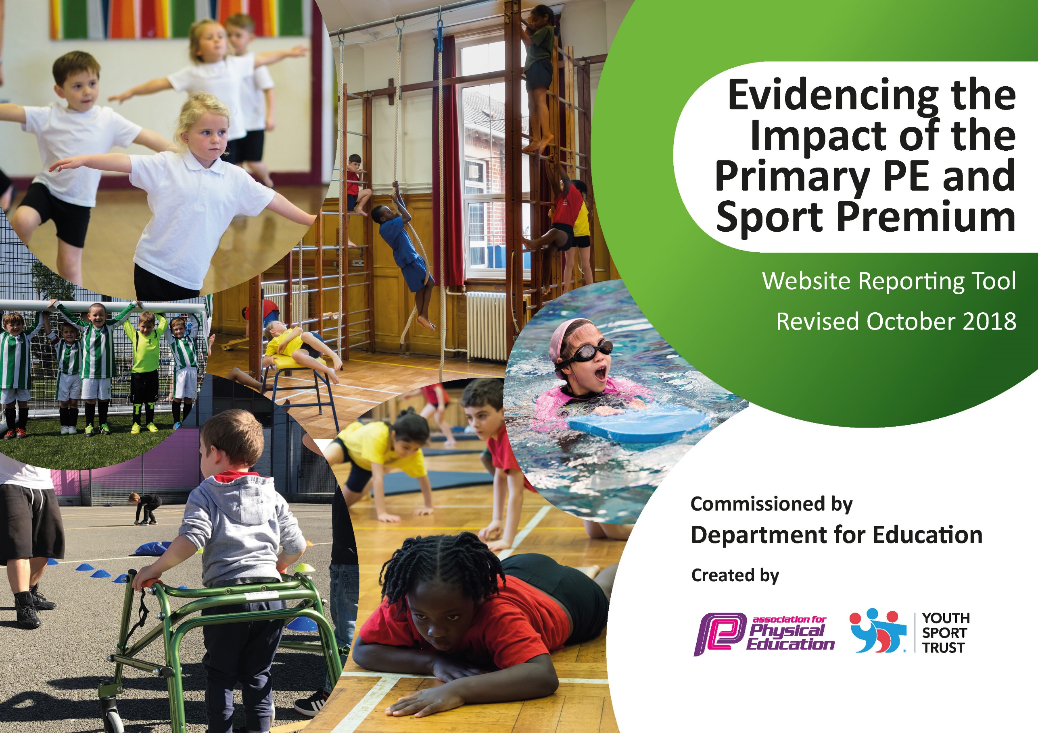
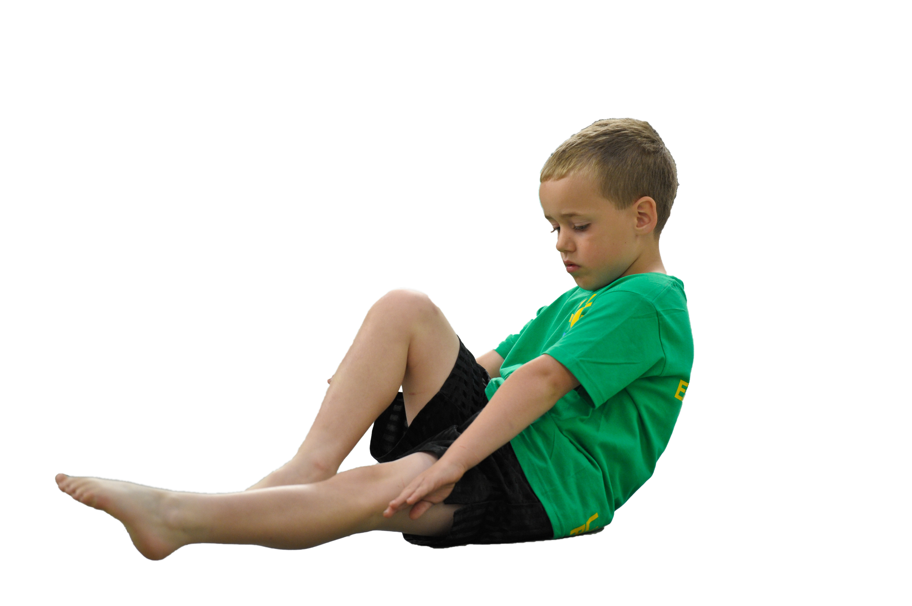
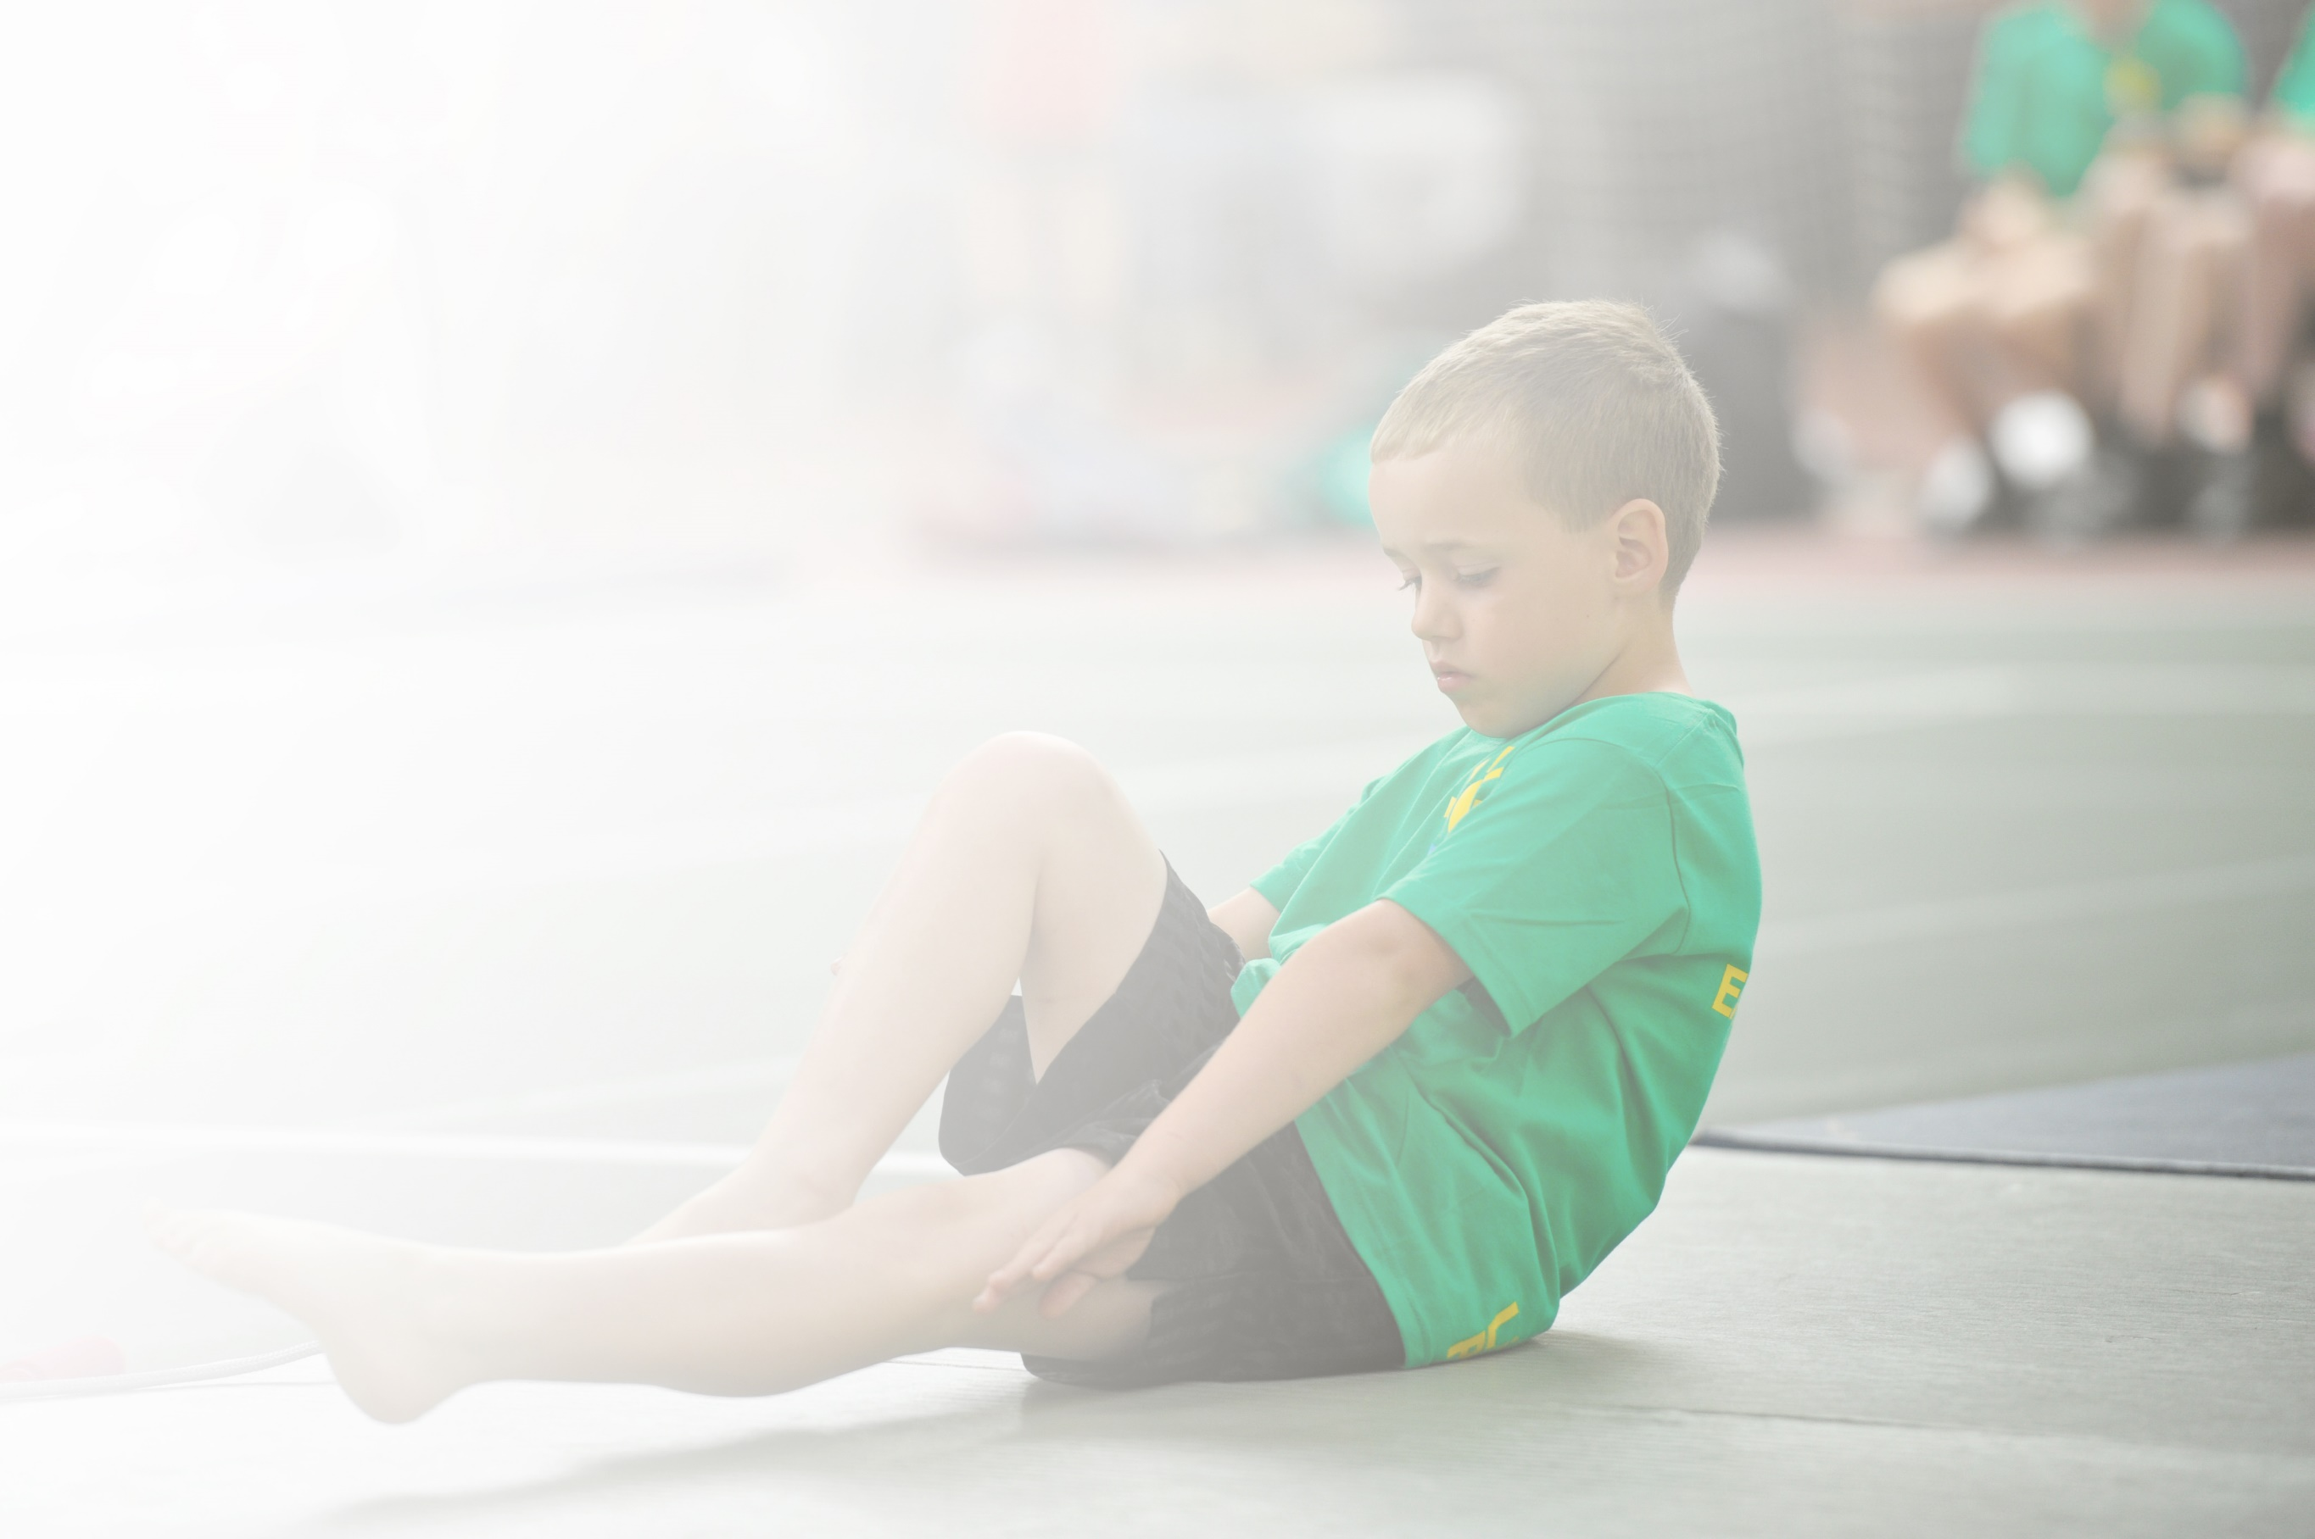
Schools must use the funding to make additional and sustainable improvements to the quality of Physical Education, Sport and Physical Activity (PESPA) they offer. This means that you should use the Primary PE and Sport Premium to:

- Develop or add to the PESPA activities that your school already offer
- Build capacity and capability within the school to ensure that improvements made now will benefit pupils joining the school in future years

Please visit gov.uk for the revised DfE guidance including the 5 key indicators across which schools should demonstrate an improvement. This document will help you to review your provision and to report
your spend. DfE encourages schools to use this template as an effective way of meeting the reporting requirements of the Primary PE and Sport Premium.

We recommend you start by reflecting on the impact of current provision and reviewing the previous
spend. Under the Ofsted Schools Inspection Framework, inspectors will assess how effectively leaders use the Primary PE and Sport Premium and measure its impact on outcomes for pupils, and how effectively governors hold them to account for this.

Schools are required to publish details of how they spend this funding as well as on the impact it has on pupils’ PE and sport participation and attainment by the end of the summer term or by 31 July 2019 at the
latest.
We recommend regularly updating the table and publishing it
on your website throughout the year, as evidence of your
ongoing review into how you are using the money to
secure maximum, sustainable impact. To see an
example of how to complete the table please
click HERE.

Support for review and reflection - considering the 5 key indicators from DfE, what development needs are a priority for your setting and your students now and why? Use the space below to reflect on previous spend, identify current need and priorities for the future.

Key achievements to date: | Areas for further improvement and baseline evidence of need:
- School Games Kitemark Gold Award (for the 4th consecutive year)  - East Staffs Boccia Champions  - Launching a successful ‘Active Play’ program | - Attempting to achieve School Games Kitemark Platinum Award for 2019/20  - Increase the number of students in Y5&6 involved in leadership in PE  - Continue to improve the fitness levels of Y5&6 students  - Increase participation of Y5&6 students in recreation and competitive sport

Meeting national curriculum requirements for swimming and water safety | Please complete all of the below:
What percentage of your current Year 6 cohort swim competently, confidently and proficiently over a distance of at least 25 metres?  N.B. Even though your children may swim in another year please report on their attainment on leaving  primary school. | 67% 25m+  (18% 15-24m / 8% 10-14m)
What percentage of your current Year 6 cohort use a range of strokes effectively [for example, front crawl, backstroke and breaststroke]? | 85%
What percentage of your current Year 6 cohort perform safe self-rescue in different water-based situations? | 93%
Schools can choose to use the Primary PE and Sport Premium to provide additional provision for swimming but this must be for activity over and above the national curriculum requirements. Have you used it in this way? | Yes

Action Plan and Budget Tracking
Capture your intended annual spend against the 5 key indicators. Clarify the success criteria and evidence of impact that you intend to measure to evaluate for students today and for the future.

Academic Year: 2018/19 | Total fund allocated: £17,590 | Date Updated: July 2019
Key indicator 1: The engagement of all pupils in regular physical activity – Chief Medical Officer guidelines recommend that primary school children undertake at least 30 minutes of physical activity a day in school |  |  |  | Percentage of total allocation:
 |  |  |  | 17%
School focus with clarity on intended impact on pupils: | Actions to achieve: | Funding allocated: | Evidence and impact: | Sustainability and suggested next steps:
Increased activity levels of pupils in relation to Government targets. | A varied program of afterschool clubs throughout the year. 2/3 x clubs weekly. | £1650 | Attendance monitored and recorded. Pupils are committed and enjoy the clubs. Increased activity levels and improved attainment levels in PE.
Increased activity levels of pupils in relation to Government targets. | A focus on ‘Active Play’ at lunchtimes to compliment the clubs ran by the teaching staff.  - Purchase of Outdoor Table Tennis tables  - Work with new lunchtime supervisor | £1400 | Increase activity levels. Engage a greater number of students in regular activity. Improved behaviour at social times. Sports Leaders helping to deliver the ‘Active Play’ program. Attendance monitored. | Support school teaching staff to oversee and support ‘Active Play’. Research outdoor gym equipment.
Key indicator 2: The profile of PESSPA being raised across the school as a tool for whole school improvement |  |  |  | Percentage of total allocation:
 |  |  |  | 17%
School focus with clarity on intended impact on pupils: | Actions to achieve: | Funding allocated: | Evidence and impact: | Sustainability and suggested next steps:
Inter House sports program throughout the year. | 1 or 2 Inter House sport competitions per term. | £0 directly. Sports Leaders trained through partnership. | More pupils participating in competitive sport.  Support the whole school House system.  Sports Leaders helping to deliver the program. | A more rigorous way of monitoring participation.
Maintaining the Gold School Games Kite mark Award to evidence that PE is embedded throughout the School. | Maintaining the high level of opportunities pupils have to participate and compete in sporting activities e.g. clubs and competitions. | £3000 | Raise profile of school success through the schools social network and website. Monitor participation. Feed pupils into local sporting pathways. | Develop the leadership program in PE to involve more students e.g. Sports Council.  Communicate regularly with the link Governor for PE.

Key indicator 3: Increased confidence, knowledge and skills of all staff in teaching PE and sport |  |  |  | Percentage of total allocation:
 |  |  |  | 5%
School focus with clarity on intended  impact on pupils: | Actions to achieve: | Funding  allocated: | Evidence and impact: | Sustainability and suggested  next steps:
High quality delivery of PE and coaching. | Use specialist coaches to support curricular and extra-curricular activities. | £800 | Improved teacher knowledge. High quality teaching provision.  Increased participation of extra- curricular and pathway links made to local clubs.  Coaches have inspired the students. | CPD for PE staff. Newly acquired knowledge of the teachers can be applied in future lessons.
Increase staff knowledge of organising a school swimming program. | AH to attend a course to aid our development of school swimming. | £75 | Facilitated AH organising and developing the Y5&6 swimming program where 67% of children can swim 25m by the end of Y6. | Moving to using the High School swimming pool as part of the MAT.
Key indicator 4: Broader experience of a range of sports and activities offered to all pupils |  |  |  | Percentage of total allocation:
 |  |  |  | 28%
School focus with clarity on intended  impact on pupils: | Actions to achieve: | Funding  allocated: | Evidence and impact: | Sustainability and suggested  next steps:
Provide extra swimming session to students in year 6 to ensure the reach the required objectives (25m) | Swimming in curricular time (Summer 1) arranged with Neil Brown at the Borough Council. | £870 | Attainment data collected at the end of the SOW. 67% children can swim 25m by the end of Y6. | Moving to using the High School swimming pool as part of the MAT.
Purchase sustainable equipment to offer a broader variety of activities on offer. | Correct sized football goals.  Handball goals.  Re-stock basic equipment. | £3800 | More sports and activities offered to the pupils (lessons, clubs, level and 2 competitions). Engaging a greater number of pupils in regular activity. Increase aspiration. Increase activity time. | Create a pathway for students to continue if they enjoyed particular activities using the local facilities.  Hire out school facilities using the new equipment.
Provide all students with a wide range of sports to engage in during NSSW focussed on Wellbeing. | Liaise with the SGO and local providers. Create a timetable of events in lessons and lunchtimes. | £205 | Students enthused by new activities.  Increased activity levels of students. Feedback from pupils. Photographs. | Create a pathway for students to continue if they enjoyed particular activities using the local facilities.
Key indicator 5: Increased participation in competitive sport |  |  |  | Percentage of total allocation:
 |  |  |  | 1%
School focus with clarity on intended  impact on pupils: | Actions to achieve: | Funding  allocated: | Evidence and impact: | Sustainability and suggested  next steps:
Continue to work with the relevant agencies to compete in the local competitions. | Join NGB’s.  Join local Partnerships.  Liaise with local schools for additional competitions. | £200  Transport costs above. | High number of students involved in competitive sport. Participation monitored.  Success at local competitions.  Events shared and celebrated on the schools social media. | Create a pathway for students to continue if they enjoyed particular activities using the local facilities.
To provide opportunities for more students to compete. | Organise regular ‘friendly’ matches to include A, B and C teams where possible, within the Uttoxeter Learning Trust. |  | Greater number of pupils engaged in competitive sport. School success. Local competitions offer greater opportunities or parental support. | Create a pathway for students to continue if they enjoyed particular activities using the local facilities.  Continue to build on the relationships with the other local middle schools.

